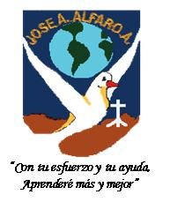

ESCUELA JOSE AGUSTIN ALFARO ALFARO
UNIDAD TECNICA PEDAGÓGICA

Nombre alumno(a): | Fecha: | Curso: 4th A
Objetivo de la Guía: Reading Comprehension of the text: My Class.
Instructions: Use English Dictionary para desarrollar la guía.

My Class

Ricardo and Alicia are in fourth grade. Ricardo is 9 years old. Alicia is 9 years old,too. Ricardo likes English. Alicia likes Phisycal Education.
They study at Jose Agustin Alfaro School in Tierras Blancas. Ricardo plays tennis on Thursday. Alicia practices violin on Friday. Their headteacher is Miss Fidelisa Reyes. Ricardo and Alicia have 24 classmates. They have English class on Tuesday.

- Read and and circle the correct answer.

- How old is Ricardo?

a) 15 b) 9 c) 18

- How old is Alicia?

a) 16 b) 5 c) 9

- Which subject does Ricardo like?

a) Religion b) Music c) English

- When do Ricardo and Alicia have English?

a) Sunday b) Saturday c) Tuesday

- Where do Ricardo and Alicia study?

a) Tierras Blancas b) La Serena c) Santiago

- Who is their headteacher?

a) Lorena Rios b) Fidelisa Reyes c) Carla Barrios

- How many classmates do they have?

a) 50 b) 9 c) 24

